ICS 141

Lab #1

1. Begin the lab by opening the Eclipse IDE. It should be available from the start menu.

2. Eclipse will ask you where you want to store your work. Enter/Create a suitable folder and click ok to continue.

3. Eclipse will then launch. You may get an introductory window if this is the first time you have used Eclipse. Close this welcome screen for now.

4. Our next goal is to create a simple Java program within Eclipse. We’ll start by creating a new Java project to store any code related to the project. To do this, click File—New—Java Project. Enter a suitable name for your project (Lab 1) and click finish.

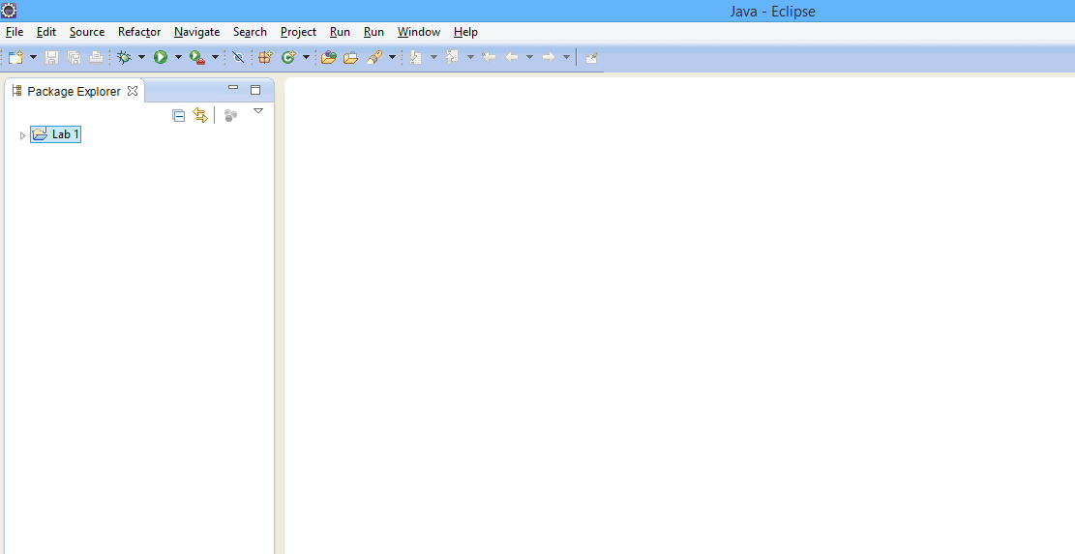

5. The next step is to create a class to put into our project. Click File—New—Class. In this menu, use the name ‘FirstLab’ as the class name. Remember, in Java, our file names must match perfectly to our chosen class name or else we will get syntax errors. Click Finish.

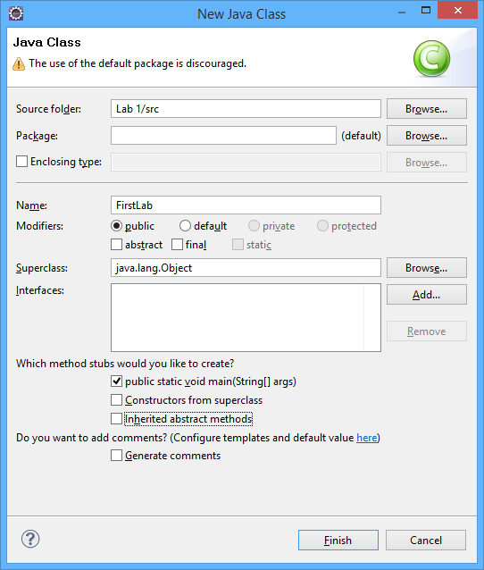

6. Eclipse will now look as follows,

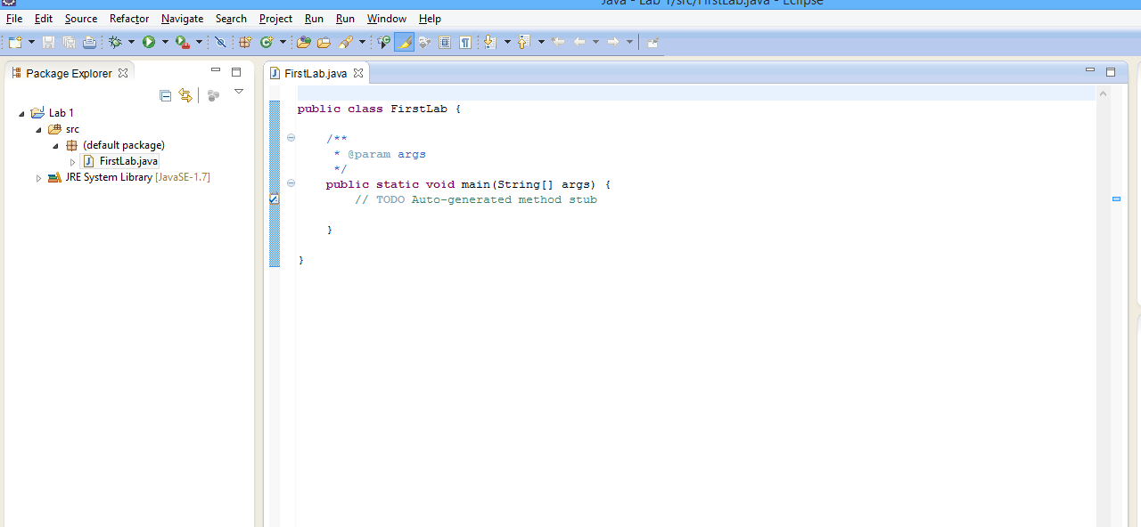

7. Write up some code that asks the user for 3 double values. Add them up and display this sum. Then, find the average and also display that value.

Save the changes by clicking File—Save.

8. Right click the FirstLab class from the project explorer. Choose **Run As** and then choose **Java Application**.

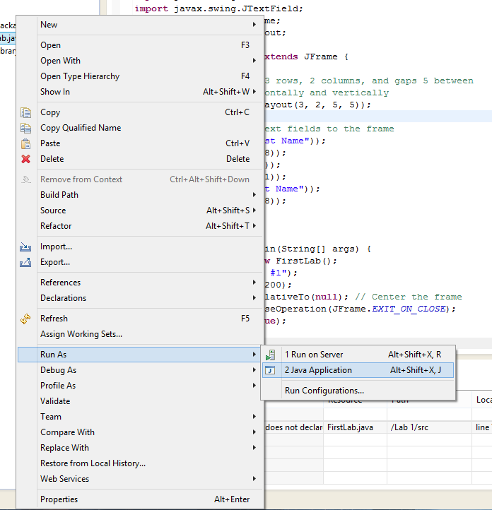

9. Either submit the source code to the dropbox or show me your work.

10. Congratulations! You have created and executed a simple program within the Eclipse IDE (It won’t be the last time!).